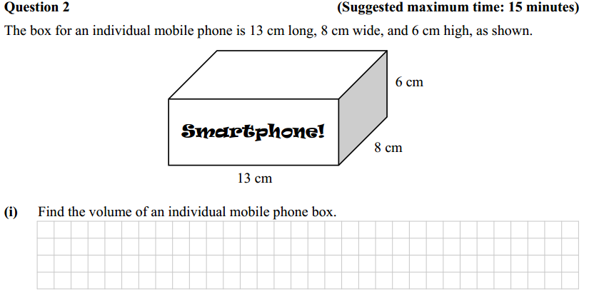
Name_______________
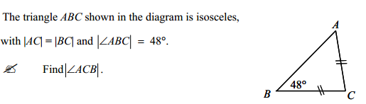
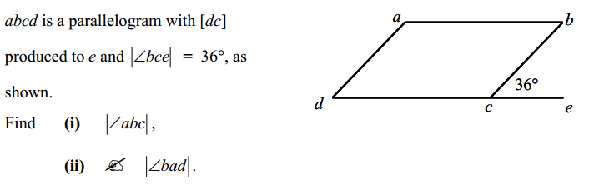

If you have time please complete the below evaluation:
How do you feel now that you have completed the exam? (Did you find it challenging or easy? Did you find difficult to complete? Etc.)
______________________________________________________________________________________
What do you think you could have done that would have had improved your learning/performance?
______________________________________________________________________________________
Did you complete all of your homework this week?
______________
Did you feel the homework was appropriate? Did you understand the task? Did you feel confident in completing it?
______________________________________________________________________________________
How much time on average did the homework take? Was this too much or too little? ______________________________________________________________________________________

